**PROG8080**

**PROGRAMMING: DATABASE MANAGEMENT**

**Assignment: 2**

1.Try to find all registered servers on your system, hint its under views (insert screenshot).

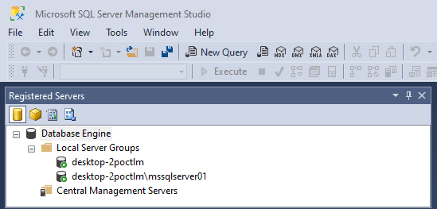

2. Disconnect from the current server and then connect again; hint you can use Object Explorer.

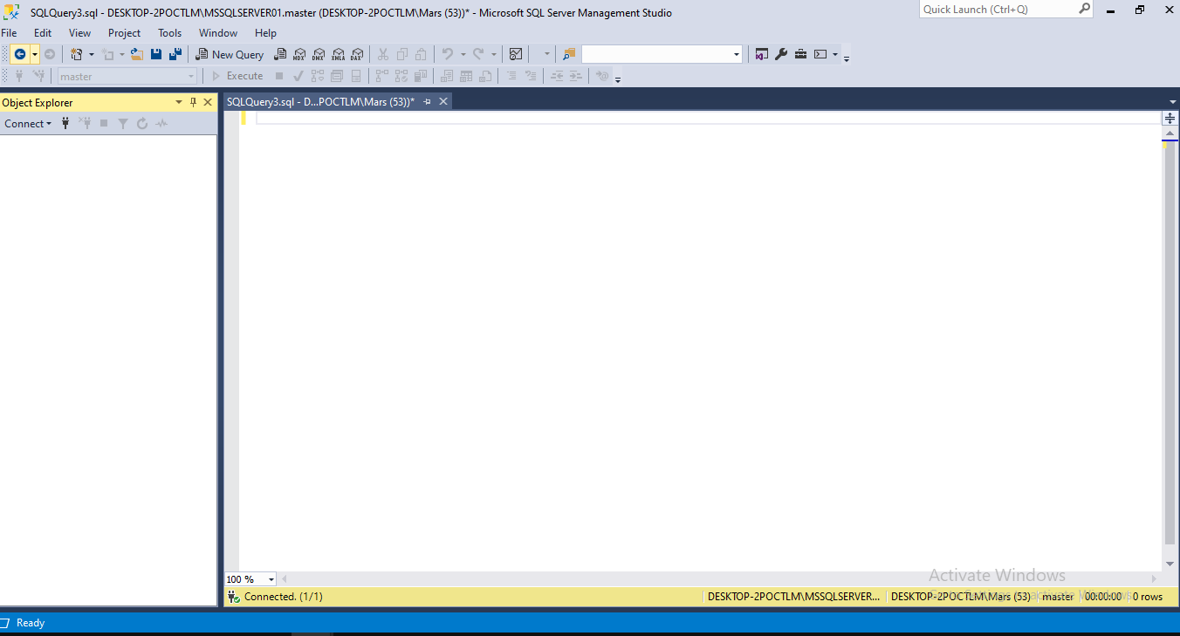

3. Display the query window, this is where you will be doing most of your work.

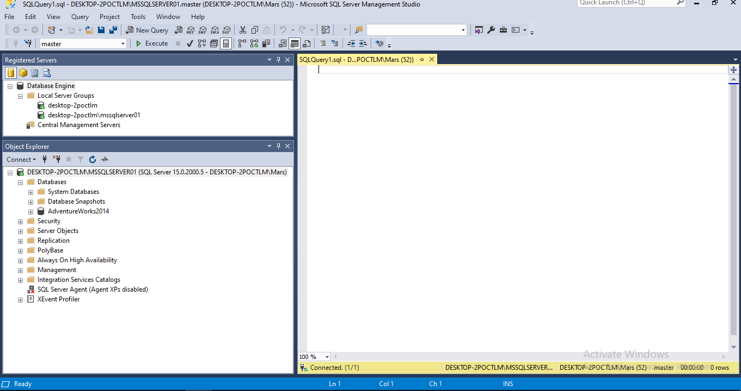

4. Open the Properties window (insert screenshot)

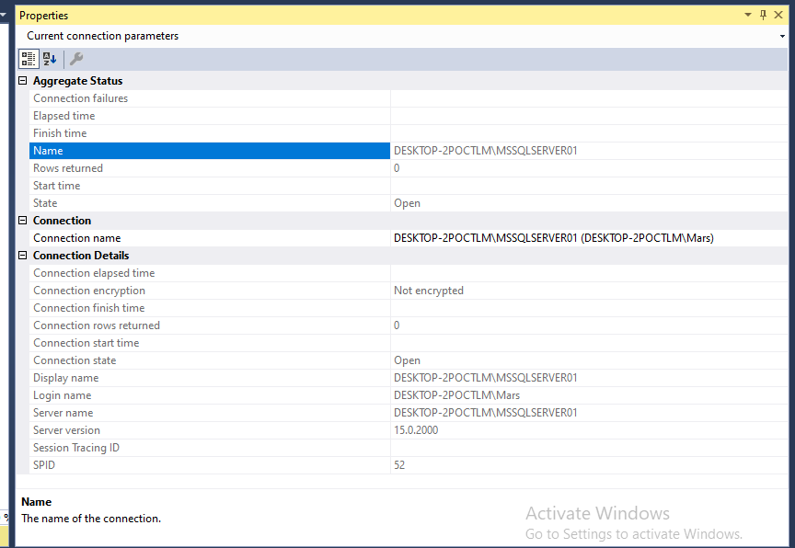

5. Display then hide, the Object Explorer Details page; hint F7 (insert screenshot of when open)

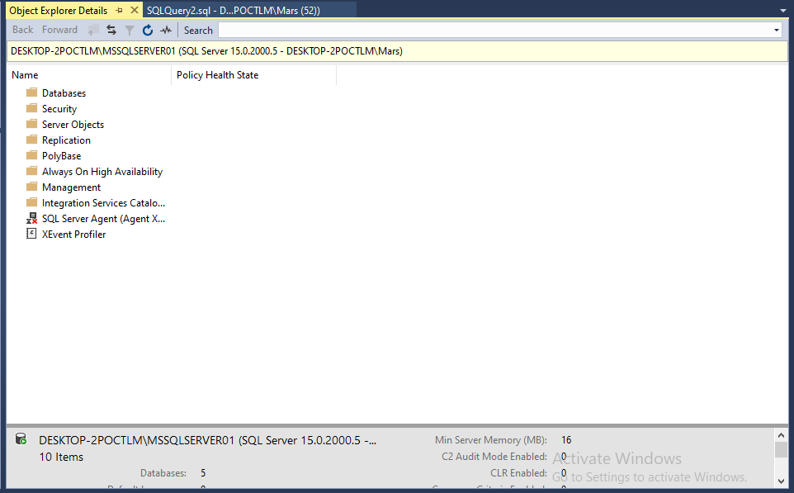

6. Configure your environment to open the Query Window when SSMS starts, test it. (insert screenshot of when choosing).

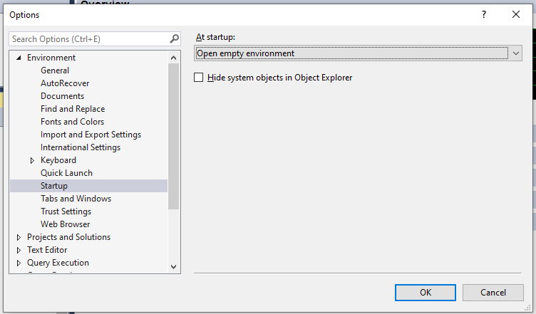

7. Now restore everything you just did by restoring to default.

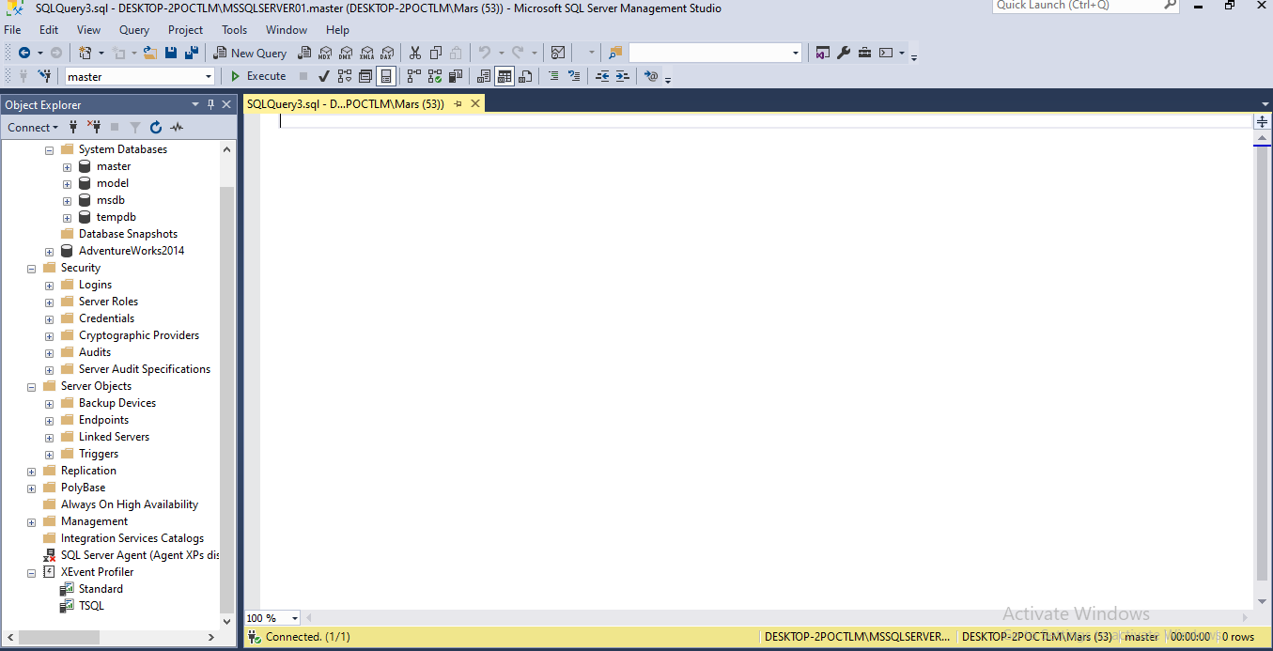

8. Attempt to run SSMS in administrator mode (in fact if you are trying to do something in the course and it gives you a permissions issue, you may have to run as administrator (insert screenshot)

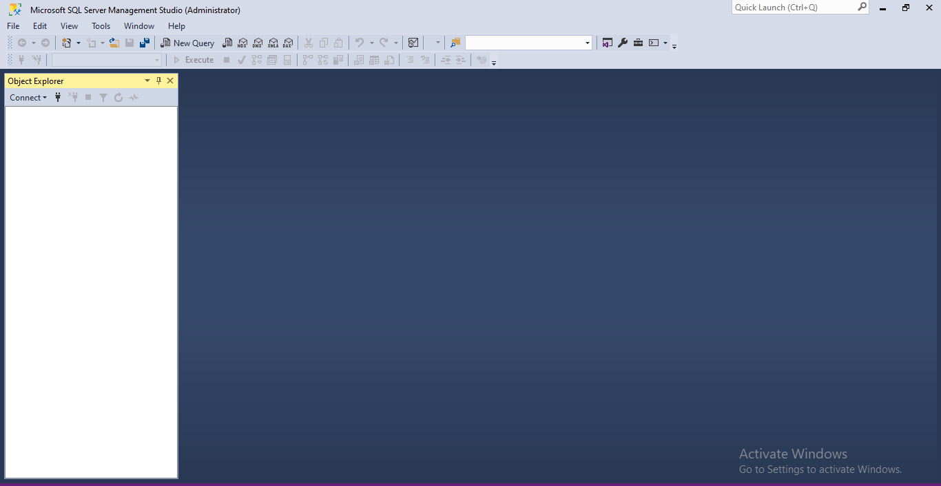

9.Disk Usage by Table for your AW database is always a good statistic to see how your database is doing in terms of disk space, try it.

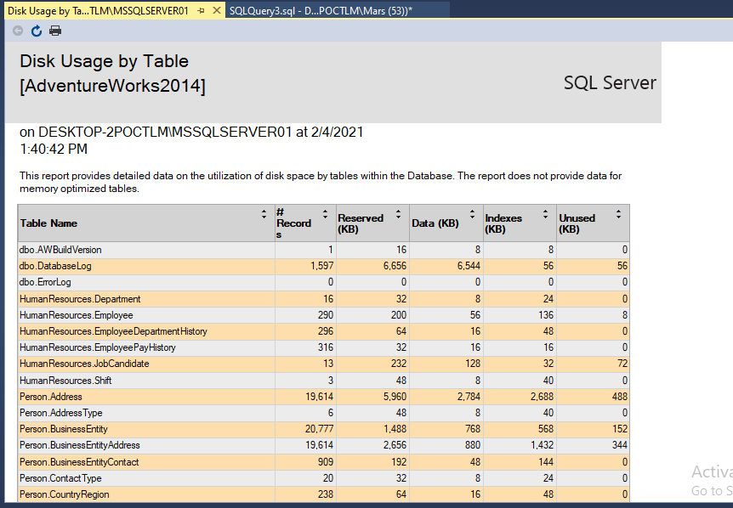

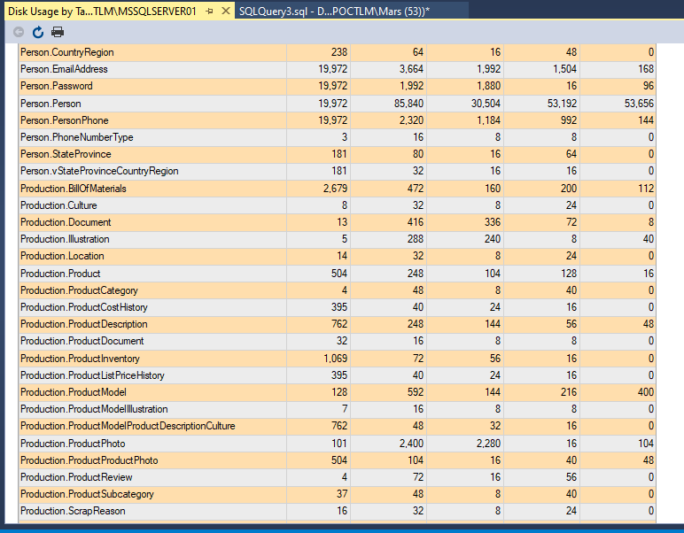

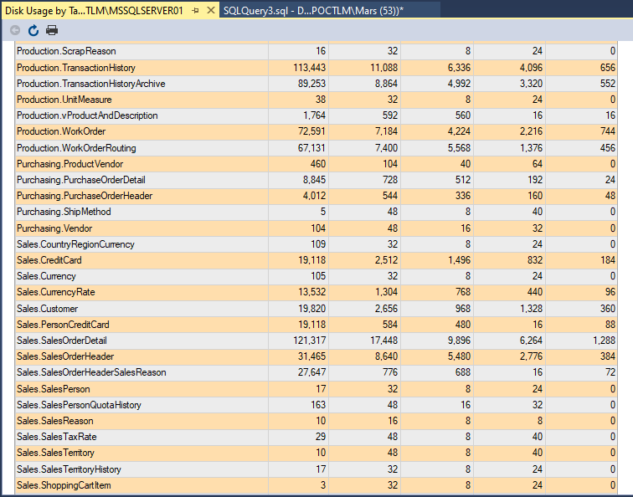

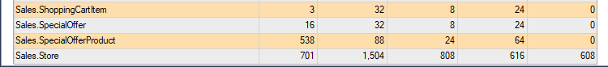

10. Now look for Top Transactions by Age. Of course, we do not have any as yet, but now go back to just Reports and see if you notice something about the options you have no compared with when we started

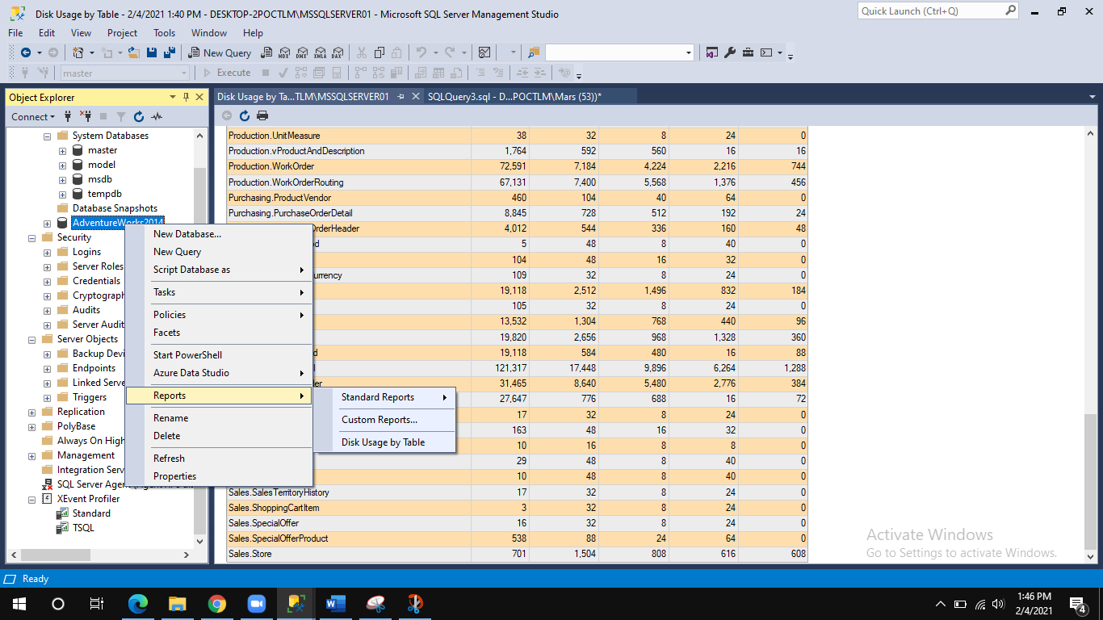

11. Attempt to find and run the Activity Monitor (insert screenshot)

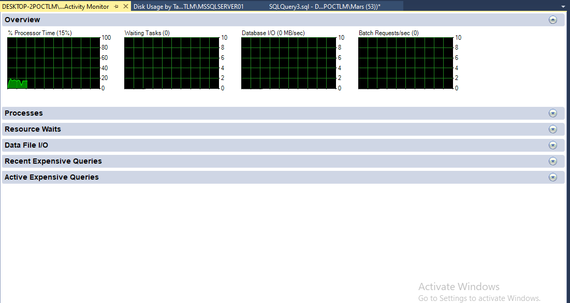

12. In OE, go down to Management -> SQL Server Logs and take a look at the current logs (view server)

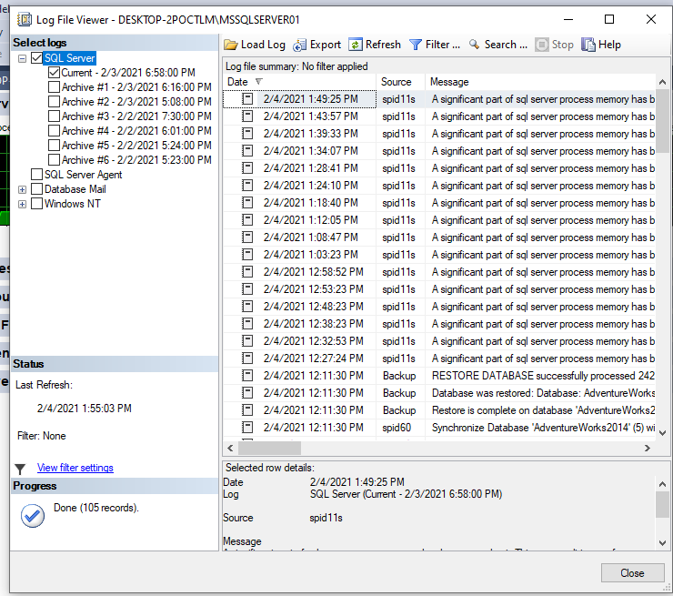

13. Right-click AW database and look at its properties. Once there look at Files (under general) there is no owner! Now, attempt to Create a DB Diagram.

You should get a warning message, about permissions. Well, it is because we have no

owner yet. Now go back into Properties of AW and enter the owner, the image below

shows MY system.

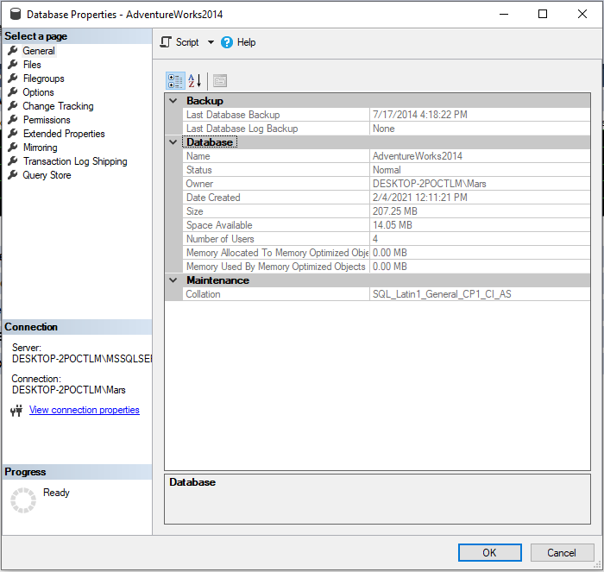

14. Check out Options in this same area (DB Properties)

